

Re: Digital health record for Mr./Ms. .....................................................................

Dear colleague

Increasing medical sub-specialization and a concommitantly rising patient mobility results in data dispersion that renders establishment and maintenance of an up-to-date, accessible and comprehensive medical health record extremely difficult.
medxchange has been founded by experienced physicians with the goal to collect, digitize and visualize personal health information via Internet or CD to our clients and their authorized physicians.
We generate a medically analyzed and and logically structured electronic patient dossier that can be safely accessed any time and any place.
This novel medical service may not only prove beneficial for your patient in emergency cases, but also provides an additional tool for you and your colleagues in efficiently assembling relevant medical data (i.e. allergies, medication, lab results, X-rays, CTs, histologies....) in an all-inclusive comprehensive patient file.
We do never interfere with your diagnostic and therapeutic conclusions, but commit ourselves to precisely and objectively collect and digitize the patients’ health history within our medical competence centers.
Your patient Mrs/Mr. .................................., date of birth, .................., city……………., gives you permission to forward all relevant data and documents generated in your practice or specialized centers at your request to the medxchange competence center. We will take care to promptly return all materials following digitization.
Most certainly, you will already benefit from our service at your clients’ next office visit.
I hereby request and authorize the transfer of my personal medical data and documents to medxchange AG, Augustinergasse 17, CH-8001 Zürich.
Date, location................................. Signature.........................................................

Please, dont hesitate to contact us in case of any questions or problems occuring.
Visit us for mor information www.medxchange.org.

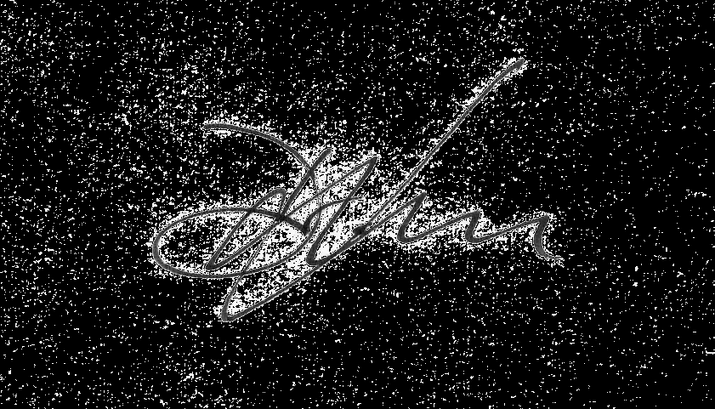Your cooperation is appreciated!
Sincerely,

Dr. med. K. Zepter Dr. med. J. Kell
Managing Director CEO medxchange

Augustinergasse 17 Tel: +41 (0) 1 212 44 46 www.medxchange.org
CH-8001 Zürich Fax: +41 (0) 1 212 44 45i nfo@medxchange.org

